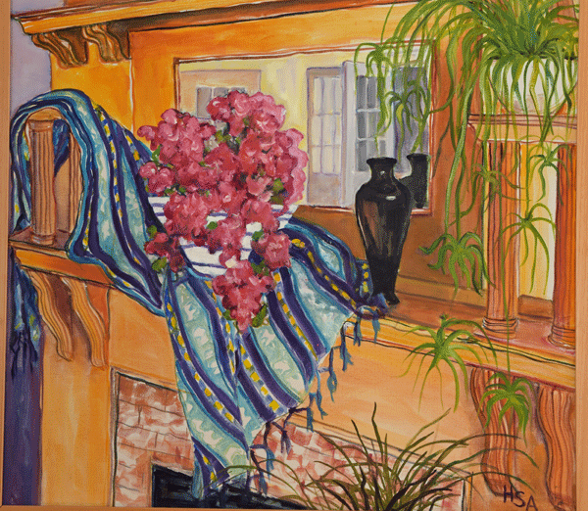

Question of the Day Podcast

We make up a story about this painting. Help us find the real artist! Listen and join the search team at:

QuestionPodcast.com

Question of the Day Podcast

We make up a story about this painting. Help us find the real artist! Listen and join the search team at:

QuestionPodcast.com

Question of the Day Podcast

We make up a story about this painting. Help us find the real artist! Listen and join the search team at:

QuestionPodcast.com

Question of the Day Podcast

We make up a story about this painting. Help us find the real artist! Listen and join the search team at:

QuestionPodcast.com